**/Dont look at the length and worry the doc is not aligned and space out/ :)**

**For Preview**

**A Collaborative project IAD - TU Darmstadt, Germany and IDC, IIT Bombay**

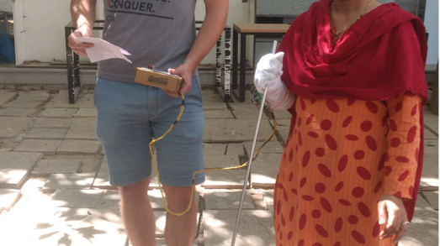

**Wearable to guide a visually impaired person to the bus stand.**

A simple glove which gives feedback in the form of vibration on inner forearm above wrist. The wearable is in the form of a glove for ease of wearing during testing to keep the vibrator fastenend in place. The feedback was generated by a wired controlled that we built using gates to give 5 types of vibration combinations.

**Concept**



**Webpage**

**Guiding system for visually impaired in public transportation - collaborative project IAD, TU Darmstadt and IDC, IIT Bombay**

Students Exchange program between Industrial Design Centre (IDC), Indian Institute of Technology Bombay, India and IAD, Technische Universität Darmstadt, Germany. This program is an attempt to promote cross cultural problem solving among participating departments of institutes of India and Germany. This project is an attempt to help the visually impaired people access public transportation with less difficulty and navigate to places of their requirement more efficiently.

**Wearable**

**Photo**

**Decisions Taken**

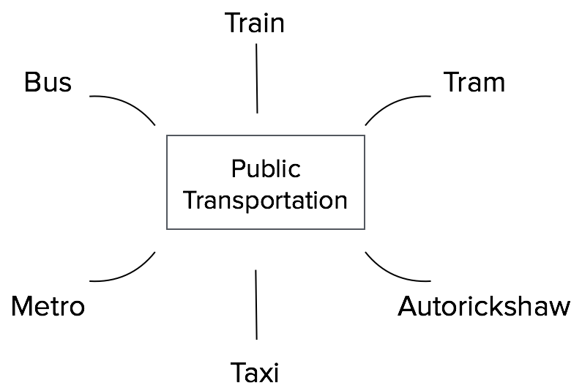

The transportation modes common to both the countries(01)

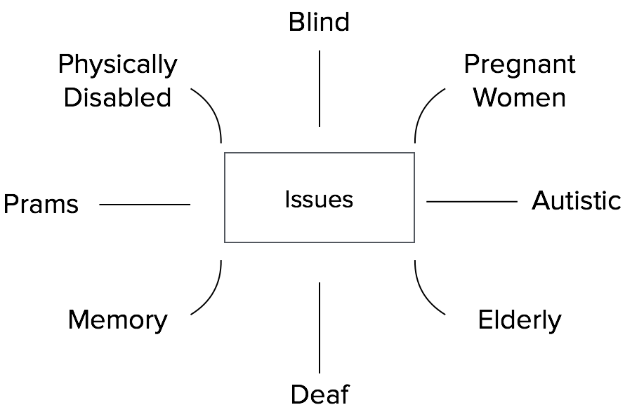

Issues to be considered while accessing public transportation(02)

From primary research and literature review done in Darmstadt and Mumbai, the main areas that need help were identified as

**Locating origin bus stop**

**Locating the right bus**

**Access the bus**

**System Overview**

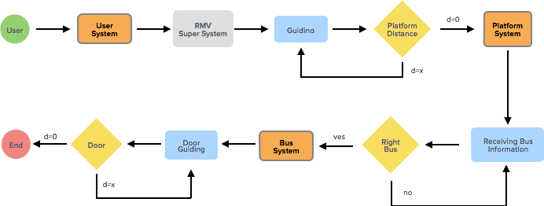

**(03)**

**Persona**

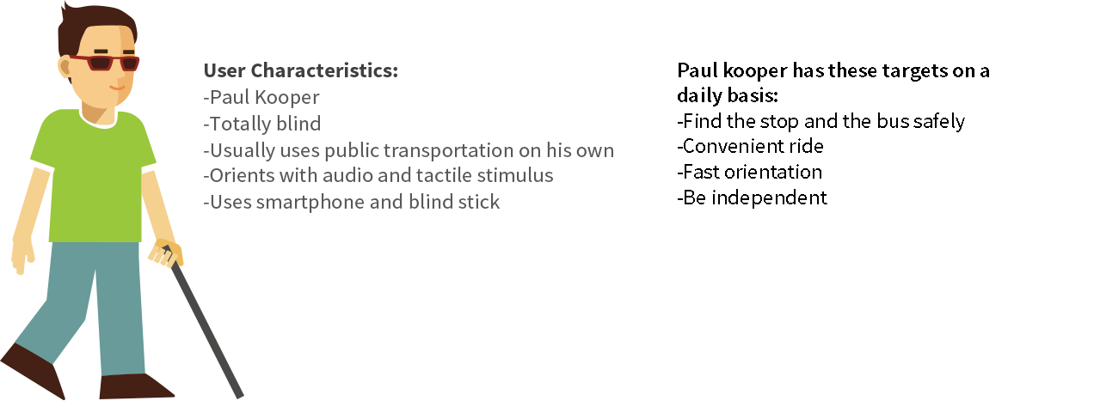

**(04)**

**Ideation - Wearable**



**(gif)**

Paul has a device on his hand that interacts with the beacon at the bus stand and directs him to the desired platform. Once at the platform, the device interacts with the correct bus and directs him to the door

**Body parts considered for wearable**

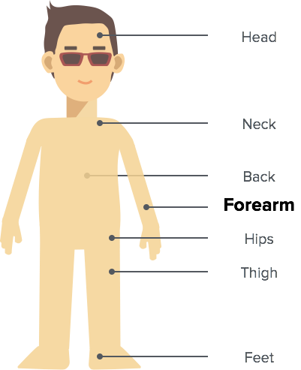

(05)

After conducting an interview with users, it was decided that forearm was the most convenient part for wearable since mobility, less interference and good feedback were considered.

**Concept**

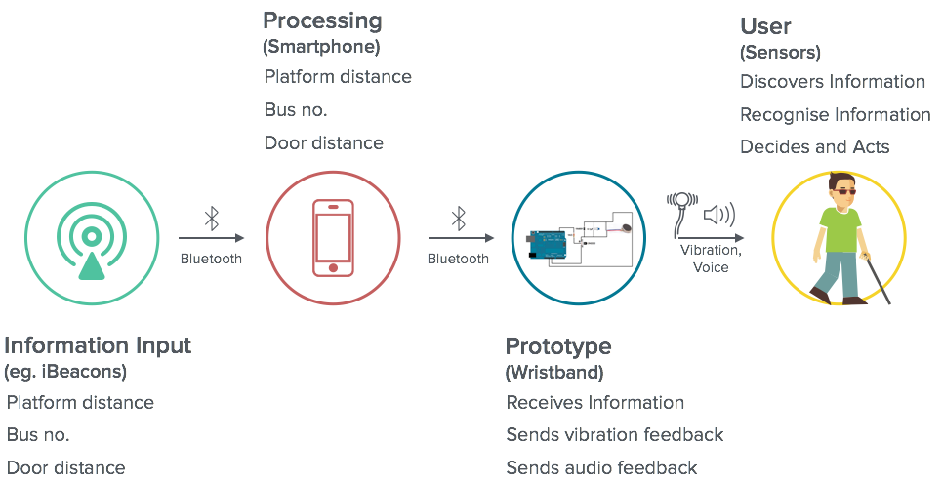

**(06)**

**Evaluation**

The first prototype was made by building a simple glove which gave feedback in the form of vibration on inner forearm above wrist. The wearable is in the form of a glove for ease of wearing during testing to keep the vibrator fastenend in place. The feedback was generated by a wired controlled that we built using gates to give 5 types of vibration combinations.



(07)

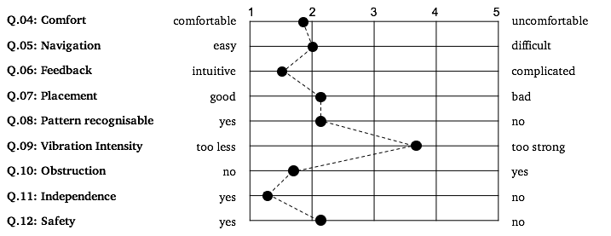

**(08)**

Download Report from this [link](https://drive.google.com/drive/folders/0B372owFok6P-MV82SXVENzVLUXM)